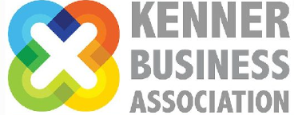

The Kenner Business Association will be hosting our Annual Give Back Event on Thursday, November 2nd at The Crossing in Rivertown. We are seeking community partners for this popular event where proceeds will be awarded to local non profits at our January 2024 meeting. This year’s recipients are Metairie Humane Shelter and the Metro Centers for Community Advocacy. Please see the attached flyer with our partnership levels.
If you or your company would like to offer a gift card for our raffle, please complete the form and return to Judy LaBella @judyhlabella@gmail.com or Mary Sharon Howland at mshowland1@gmail.com by October 20th.

BUSINESS NAME__________________________________________________________
Contact Person_____________________________________________________________
Address_____________________________________________________________________
Phone_______________________Email__________________________________________
Description________________________________________________________________________________________________________________________________________________________________________________________________________________________________________________________________________________________________________
Value of Item:______________________________________________________________

